19 CSE 102 Computer Programming

# LAB 2 - PART 1- OPERATORS AND DECISION MAKING

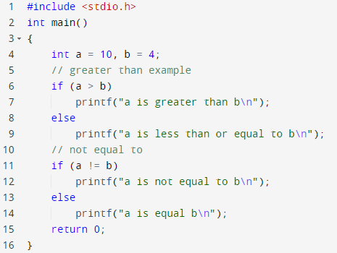

Output: a is greater than b

a is not equal to b

2. Find the output of the following program

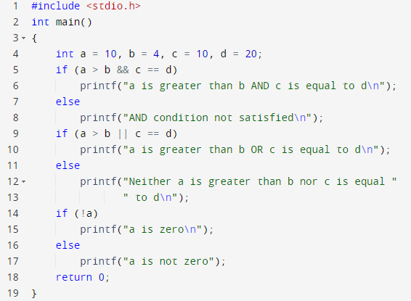

Output : AND condition not satisfied

a is greater than b OR c is equal to d

a is not zero

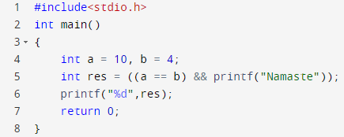

Output: 0

Explanation: The output is zero because the condition res=((a==b) is false ie 0 in decimal form as a=10 and b=4.

1. Find the output of the following program and explain the reason leading to the output

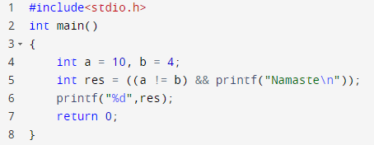

Output: Namaste

1

Explanation: The output was Namaste and 1 because the condition res=(a!=b)& printf returns true for the value of a and b and as printf has some value.

as 10 and 4 so the printf function was executed because of the && and the output came.

1. Find the output of the following program and explain the reason leading to the output

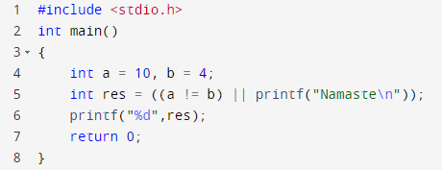

Output :1

Explanation: The value of res becomes 1 as it is of integer type and the condition is true. So, it does not go for the printf statement due to || operator .

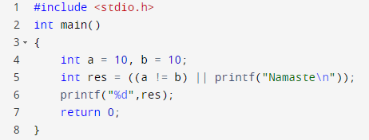

Output: Namaste

1

Explanation: The condition above is true which is assigned to integer variable res so res stores the value 1 because of the or and printf function used there. If the first function is false then only it goes to printf in this case.

1. Find the output of the following program and explain the reason leading to the output

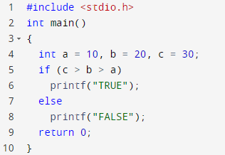

Output: False

Explanation: comparisons like 'X<Y<Z' do not have their mathematical meaning in c programming

1. Find the output of the following program and explain the reason leading to the output

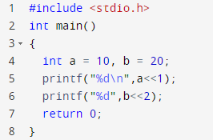

Output: 20

80

Explanation : The left assignment operator shifts the digits by converting it into binary.

1. Find the output of the following program and explain the reason leading to the output

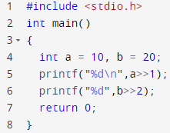

Output:5

1

Explanation: The right assignment operator works there.

1. 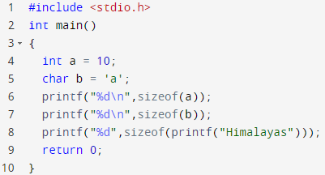Find the output of the following program and explain the reason leading to the output

Output:4

1

4

Explanation: size of function shows the memory space for the given data.int=4 char=1 str=4 ld=8

11.Find the output of the following program and explain the reason leading to the output

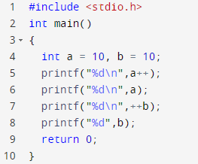

Output:10

11

11

11

Explanation: The a++ is post assignment operator which works after it is executed and ++b is ore assignment operator so it add 1 and displays the result.

12.Find the output of the following program and explain the reason leading to the output

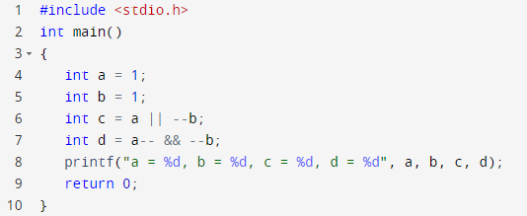

Output: a = 0, b = 0, c = 1, d = 0

Explanation: The post and pre assignment operator played role in changing values.

1. Find the output of the following program and explain the reason leading to the output

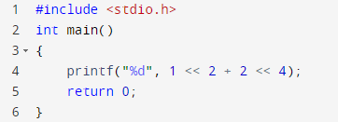

Output: 256

Explanation: The left as well as right shifting operator worked here which changed the data. And + has higher priority so 1 <<4<<4.

1. Find the output of the following program and explain the reason leading to the output

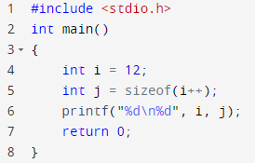

Output: 12

4

Explanation: The size of function allotted the memory space of I which is 4 .

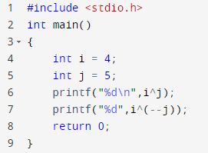

Output: 1

0

Explanation: The ^ sign denotes the xor operation.

1. Find the output of the following program and explain the reason leading to the output

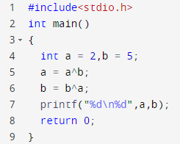

Output: 7

2

Explanation: The xor bitwise operation.

1. Given the code to swap two variables without a third variable using + and – operators. Can you try to write a code to swap variables without using a third variable using the ^ operator.

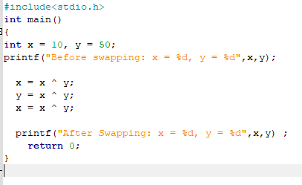

18.Find the output of the following program and explain the reason leading to the output

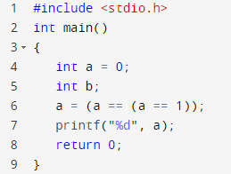

Output : 1

Explanation: It is checking for conditions withy Boolean values and assigning it .

19. Find the output of the following program and explain the reason leading to the output

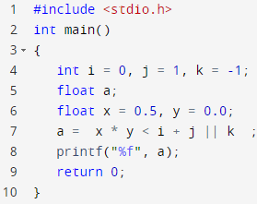

Output : 1.00000

Explanation : Just the mathematical functions are performing in priority order

Order: BODMAS <> & &&

1. Which BITWISE operator is to be used in line number 7 for the value in variable ‘c’ to be 6? What is the value in variable ‘z’?

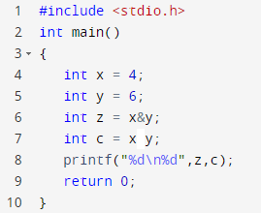

Answer: Bitwise or operator should be used between x and y to get the output of c as 6.The value in ‘z’ is 4.

1. Akshay and Rohith are playing a game. The game is such that Akshay has to find out the number in a series of 5 numbers which are given by Rohith (all the numbers are greater than 0). Now, out of the 5 numbers only one number is not a duplicate of any other number,

i.e every other number except one number has a duplicate. Help Akshay write a program that finds the number not having a duplicate and displays the same as the output. [Please understand that you are not supposed to use == operator or loops or an array(s) or any built in function other than printf and scanf)]

## Input

4

6

10

4

6

## Output

10

#include<stdio.h>

int main()

{

int a,b,c,d,e;

printf("Enter 5 numbers ");

scanf("%d%d%d%d%d",&a,&b,&c,&d,&e);

int f= (a ^ b ^ c ^ d ^ e);

printf("The number which is not having any duplicate is %d",f);

return 0;

}

1. Nivedita and Hima are playing a game to determine whether a number mentioned by Hima is even or odd. However, Nivedita is not supposed to use /, %, - or + operators. Help Nivedita to write a program that can determine whether the number mentioned by Hima is even or odd

## Input

4

## Output

Even

#include<stdio.h>

int main()

{

int a;

printf("Enter a number ");

scanf("%d",&a);

int f= (a & 1);

printf("%d",f);

return 0;

}

Note : The least significant digit of odd number is 1 and even is zero.

1. Find the output of the following program and explain the reason leading to the output

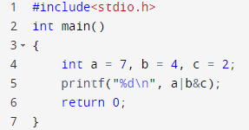

Output: 7

Explanation: first b&c runs then a|b.